Critical Thinking 4 Option 2

Harshil Patel

Colorado State University – Global Campus

**Code and Outputs**

**# R Hypothesis Tests**

**install.packages("dplyr")**

**tScore_before <- c(40, 62, 74, 22, 64, 65, 49, 49, 49)**

**tScore_after <- c(68, 61, 64, 76, 90, 75, 66, 60, 63)**

**# Create a data frame**

**my_data <- data.frame(**

**group = rep(c("Score Before", "Score After"), each = 9),**

**scores = c(tScore_before,  tScore_after)**

**)**

**# Print all data**

**print(my_data)**

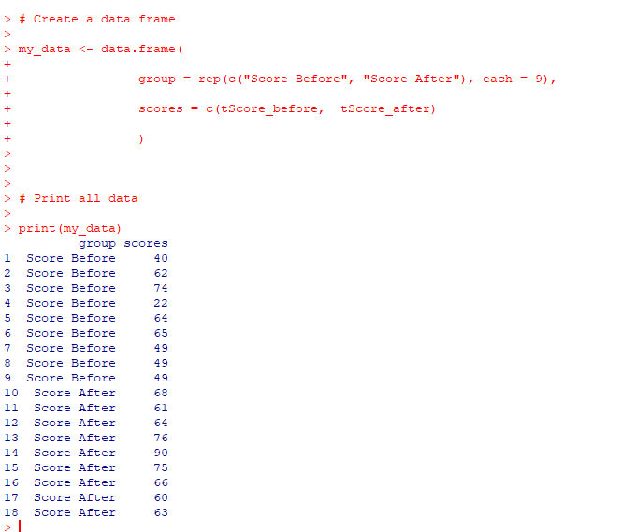

**#Compute summary statistics by groups**

**library(dplyr)**

**group_by(my_data, group) %>%**

**summarise(**

**count = n(),**

**mean = mean(scores, na.rm = TRUE),**

**sd = sd(scores, na.rm = TRUE)**

**)**

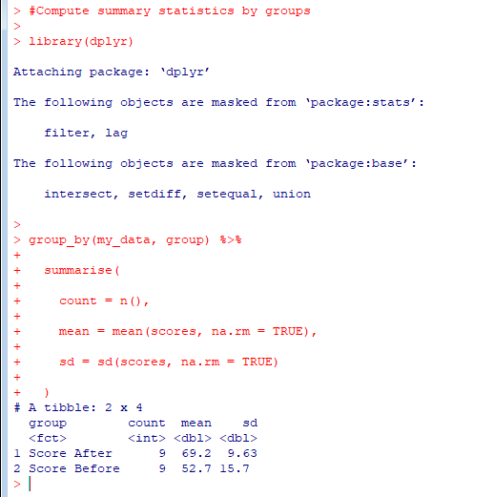

**# Compute Unpaired Two Sample t-test**

**res <- t.test(tScore_before, tScore_after, var.equal = TRUE)**

**res**

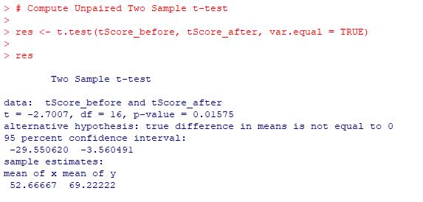

**# Compute independent t-test**

**res <- t.test(scores ~ group, data = my_data, var.equal = TRUE)**

**res**

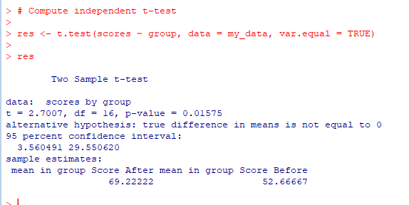

**#test whether the average score before score is less than the average after score, type this:**

**t.test(scores ~ group, data = my_data,**

**var.equal = TRUE, alternative = "less")**

